**Instructions for using the Microsoft CMT system**

**(For contributors)**

**ICCWAMTIP2024 conference affairs organization**

**(University of Electronic Science and Technology of China)**

**October 2024**

Step 1. Log in to the CMT system

Log in to the CMT site: <https://cmt3.research.microsoft.com/User/Login>

If you already have a CMT account, enter your account password to log in. If you don't have a CMT account, click "New to CMT?" in the bottom right corner. Register" Note: Please use your usual personal email address as your registered email address, and subsequent relevant notices will be sent to the CMT registered email address.

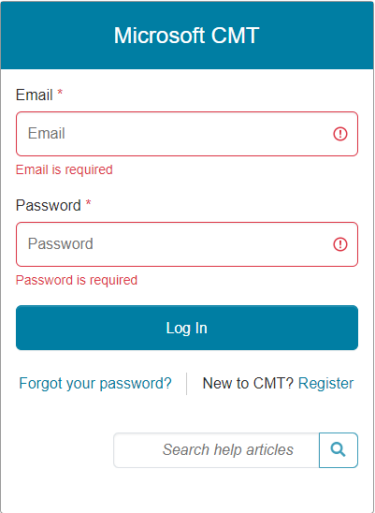

Step 2 Search for and go to the ICCWAMTIP2024 meeting submission page

a、点击All Conferences

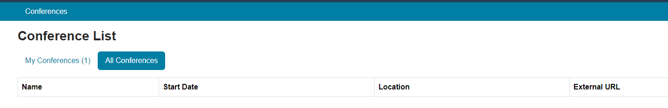

b. Enter wavelet in the search bar at the top right to find the top meeting (as shown in the figure below), and click to enter

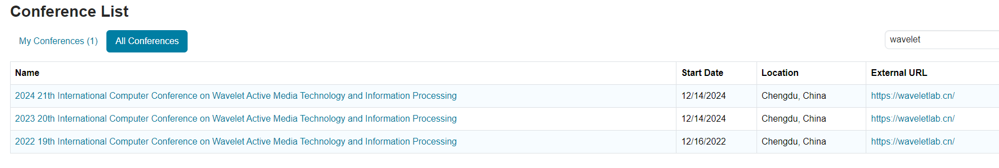

Step 3. Create a request

Press “+ Create new submission” button，to create an application。

Note: Each person only needs to create one application per article, and you can edit it repeatedly, and you don't need to create a new application

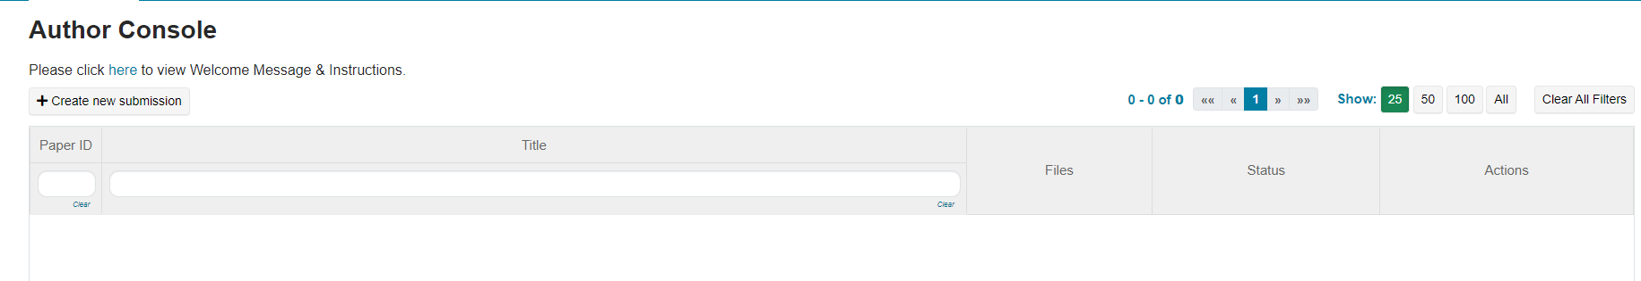

Step 4. Fill in the application information

（1）Fill Title and Abstract、SUBJECT AREAS，Authors，and upload your FILES（doc, docx format allowed, PDF Not accepted）

(2) After completing all the relevant questions, please click the "Submit" button at the bottom of the page to submit. If the submission is not successful, please check that the required fields have been completed.

(3) If the submission is successful, after returning to the "Author Console" interface, you can see the detailed filling of the question by clicking the ID; Before the deadline, the application materials and related information can be revised repeatedly through the "Edit Submission". Note: Clicking "Delete Submission" will delete the entire application. Therefore, please be careful not to delete your application by mistake. If you encounter other questions during the submission process, Please contact the group owner and conference contact person through QQ group 996496077 or by other contact information (provided on our official website)

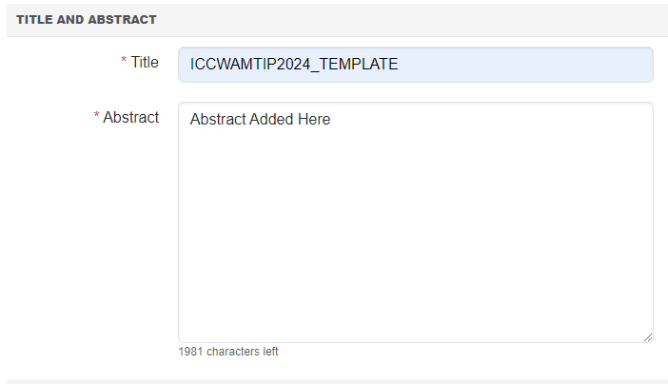

Fill in the title and abstract as normal

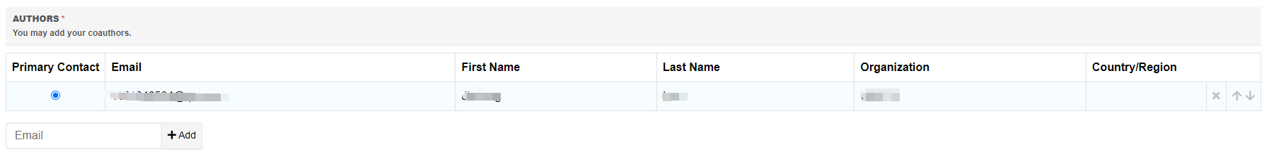

This will be automatically filled with personal information, and if you want to add 2 or 3 relevant information, you can click here Add

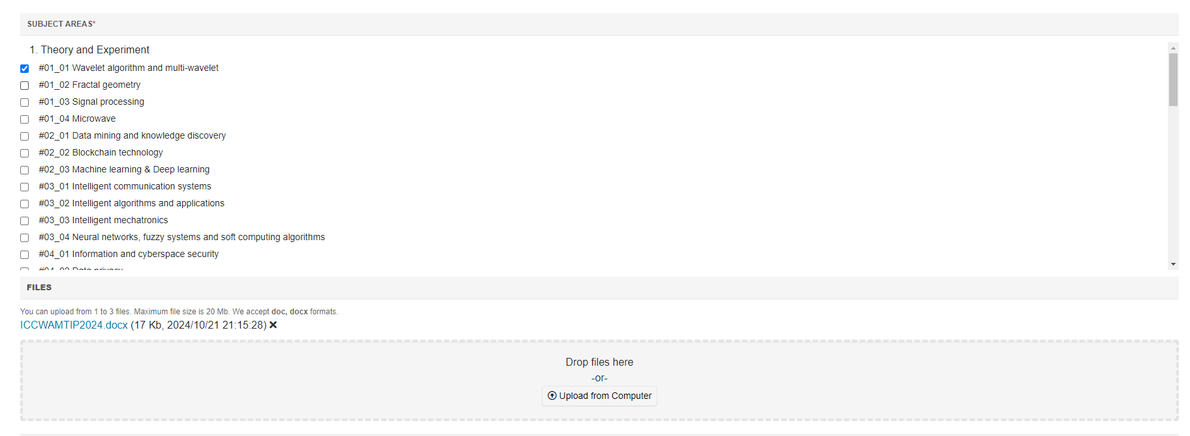

Select the subject area and upload the body file in the corresponding format (note that the minimum requirement is 4 pages)

For specific body format requirements, please refer to the paper-format.dotx file, note that the format will be sent back for re-correction if the format is unqualified. （This document can also be found on the official website）

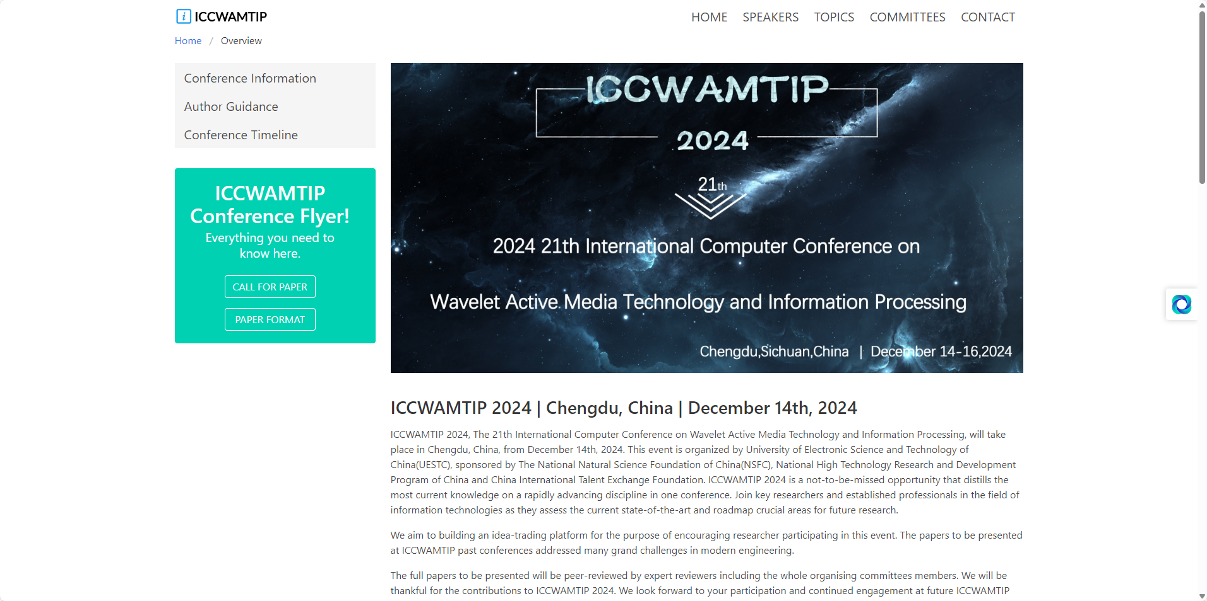

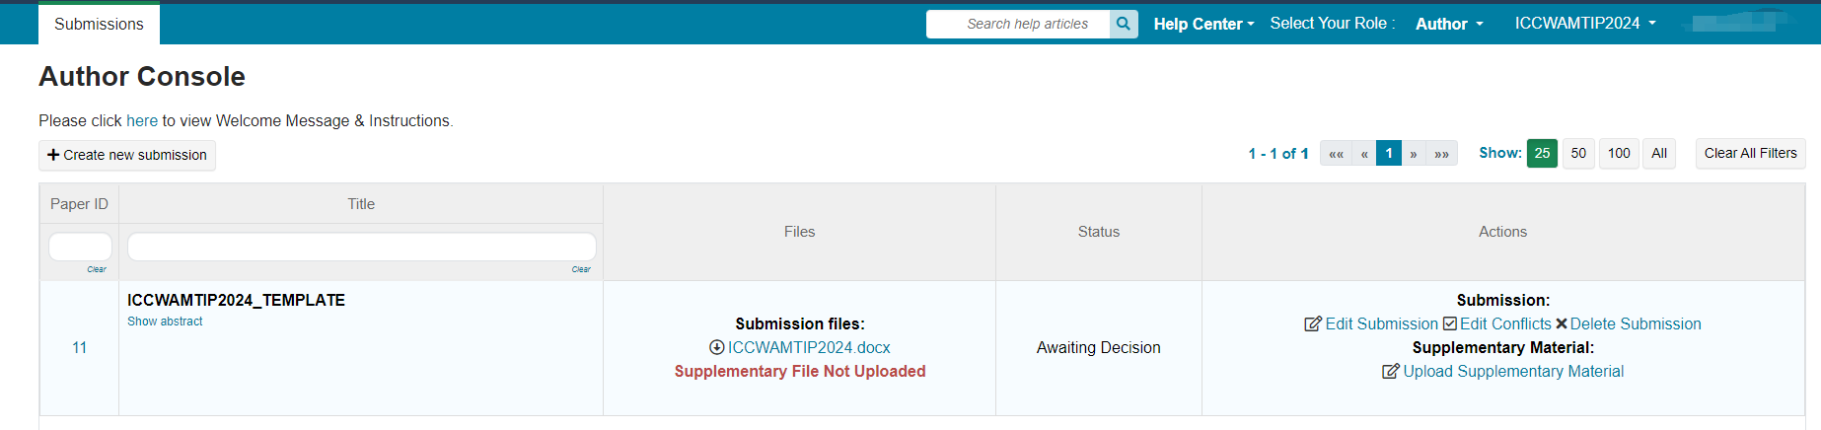

On this page, you can view the status of the article, and you can also modify the submission information and submitted materials from the Actions on this page